LETTER OF UNDERTAKING

I Adnan Khan Student VU ID BC230406160 hereby confirm that the OAR I have provided is solely my own effort. I did not copy my report partially or completely from any other student or from any other source either against payment or free and I did not provide any plagiarized material in any section of my report. I further confirm that the documents (Job Confirmation Letter, etc.) that I have provided are genuine (i.e. not forge/fake) and have been issued by the authorized person in the organization. If I am found guilty of misstating, misleading or concealing the facts about my activities (either academic or non-academic but relevant to this course) at any stage, the university is authorized to take disciplinary action against me according to university policies and regulations.

I hereby also confirm that I have carefully read and understood all the guidelines, rules and regulations provided by the course instructor on VULMS. I assure that I will follow the instructions regarding presentation & viva voce and will appear on the scheduled date for presentation & viva voce which will be intimated to me at my VU-email ID by the Course Instructor. In case of any negligence, I shall be held responsible.

Name: Adnan Khan
Signature: 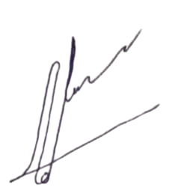
Date: 30 November 2025

